ENGLISH 7 UNIT 2

**PERSONAL INFORMATION**

PART A: **TELEPHONE NUMBERS**

1. **READ:**

**TELEPNONE DIRECTORY**

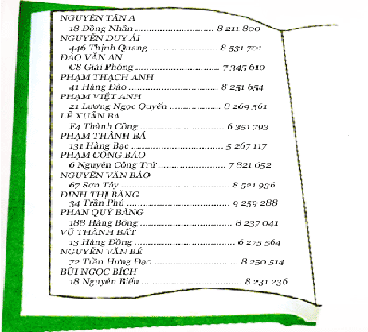

1. Dao Van An **7345610**: *seven - three - four - five - six - one - oh*.
2. Pham Viet Anh **8269561**: *eight - two - six - nine - five - six - one*.
3. Pham Thanh Ba **5267117**: *five - two - six - seven – double one - seven*.
4. Dinh Thi Bang **9259288**: *nine - two - five - nine - two - double eight*.
5. Vu Thanh Bat **6275564**: *six - two - seven - double five - six - four*.
6. Bui Ngoc Linh **8231236**: *eight - two - three - one - two - three- six*.

***HOW TO SAY TELEPHONE NUMBERS***

* 8995134: eight, **double** nine, five, one, three, four
* 8571017: eight, five, seven, one, **zero**, one, seven
* 7535**666**: seven, five, three, five, **six, double six**

1. **LISTEN AND WRITE THE TELEPHONE NUMBERS**:

Students study by themselves at home

1. **LISTEN:**

Lan: Excuse me, Hoa.

Hoa: Yes, Lan?

Lan: What’s your telephone number?

Hoa: 8 262 019.

Lan: Thanks. I’ll call you soon.

*Now ask your classmates and complete the list*

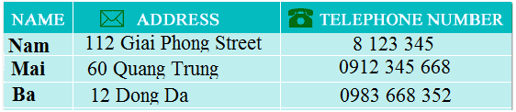

1. **LISTEN AND READ. THEN ANSWER THE QUESTIONS**



**Phong:**  Hello. This is 8 537 471.

**Tam:**  Hello. Is this Phong?

**Phong:**  Yes. Who’s this?

**Tam:** It’s me, Tam. Will you be free tomorrow evening?

**Phong:**  Yes, I will

**Tam:** Would you like to see a movie?

**Phong:**  Sure. What time will it start?

**Tam:** It’ll start at seven o’clock.

    Let’s meet at 6.45.

**Phong:**  Where will we meet?

**Tam:**  We’ll meet in front of the movie theater.

**Phong:** Great. I’ll see you tomorrow. Don't be late!

**NEW WORDS**

* personal information (n)
* telephone number (n)
* telephone directory (n)
* excuse me
* call (v)
* free (adj.)
* tomorrow (n)
* movie (n)
* movie theater (n)

**GRAMMAR:**

**THE SIMPLE FUTURE TENSE**

* ***Formation:***

|  |  |  |
| --- | --- | --- |
| **(+)** | **S + will + V** |  |
| **(-)** | **S + won't + V** | **won't = will not** |
| **(?)** | **Will + S + V …?** |  |

* ***Notes***

Thì tương lai diễn tả một việc sẽ xảy ra trong tương lai, thường dùng với các từ chỉ thời gian như sau: **TONIGHT, TOMORROW, NEXT WEEK, NEXT MONTH, NEXT YEAR, SOON, …**

* ***Example:***
* I **will go** to the zoo next Sunday.
* **Wil**l she **be** here on time?
* No. She **will not be** here on time.

**STRUCTURES:**

* **What’s your telephone number?**

**8 262 019**

* **Who’s this?**

**It’s Tam.**

* **Would you like + TO + V…..?**

**Would you like to see a movie?**

* **Let’s + V….**

**Let’s meet at 6.45.**

**Answer the questions**

**a)** Who will meet tomorrow?

=> Tam and Phong will meet each other tomorrow.

**b)** What will they do?

=> They will see a movie.

**c)** What time will they meet?

=> They will meet at 6.45.

**d)** Where will they meet?

=> They will meet in front of the movie theatre.

1. **LISTEN. THEN WRITE THE ANSWERS**

**Students study by themselves at home.**

1. **READ. THEN ANSWERS**

**Students study by themselves at home.**

1. **PLAY WITH WORDS:**

**Students study by themselves at home.**